LAB # 4

QUESTION NUMBER 1:

PROGRAM:

#include <iostream>

using namespace std;

int main()

{

cout << "This program will help to take input form the user and sum it then will display it" << endl;

int \*Array = NULL;

int size,sum=0;

cout <<endl<< "Enter the Number of the Students : ";

cin >> size;

Array = new int[size];

cout << endl;

for (int i = 0; i < size; i++)

{

cout << "The marks of student " << i + 1 << " is : ";

cin >> \*(Array + i);

sum = sum + \*(Array + i);

}

cout <<endl<< "Total marks of the students are : "<<sum<<endl;

delete []Array;

Array=NULL;

cout << endl << endl;

system("pause");

}

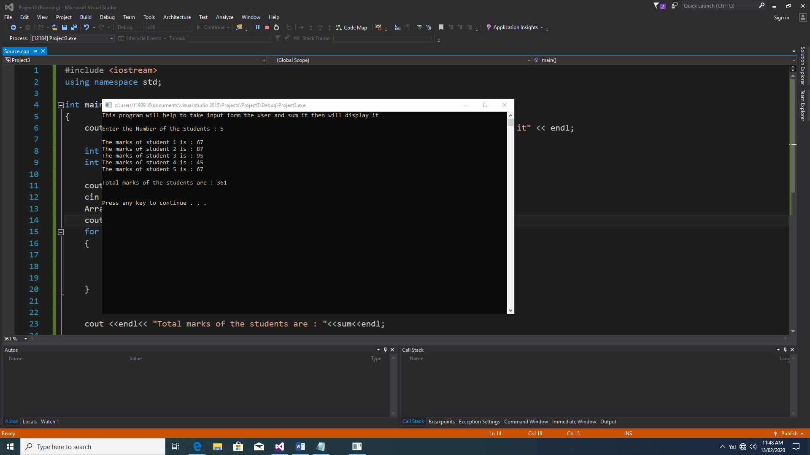

QUESTION NUMBER 2:

PROGRAM:

#include <iostream>

using namespace std;

int main()

{

cout << "This program will help to take input form the user and sum it then will display along with the number of students" << endl;

int \*Array = NULL;

int size,sum=0;

cout <<endl<< "Enter the Number of the Students : ";

cin >> size;

Array = new int[size];

cout << endl;

for (int i = 0; i < size; i++)

{

cout << "The marks of student " << i + 1 << " is : ";

cin >> \*(Array + i);

sum = sum + \*(Array + i);

}

cout <<endl<< "Total marks of the students are : "<<sum<<endl;

delete []Array;

Array=NULL;

cout << endl << endl;

system("pause");

}

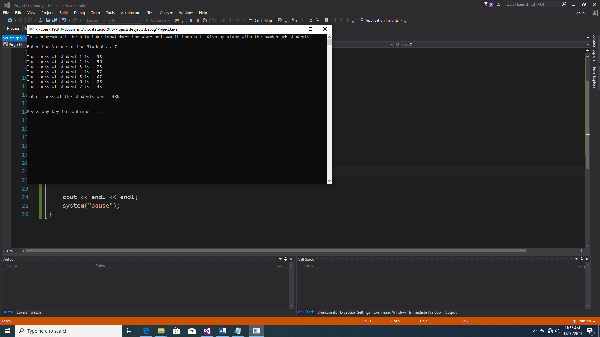

QUESTION NUMBER 3:

PROGRAM:

#include <iostream>

using namespace std;

int main()

{

cout << "This program will help to take input form the user and shows the maximum number " << endl;

int \*Array = NULL;

int \*MAX1=NULL;

int size;

cout <<endl<< "Enter the Number of the Students : ";

cin >> size;

Array = new int[size];

cout << endl;

MAX1 = Array;

for (int i = 0; i < size; i++)

{

cout << "The marks of student " << i + 1 << " is : ";

cin >> \*(Array + i);

if (\*MAX1 <= \*(Array + i))

{

MAX1 = (Array + i);

}

}

cout << "Maximum number from the given numbers of students is : "<<\*MAX1 ;

delete []Array;

Array=NULL;

cout << endl << endl;

system("pause");

}

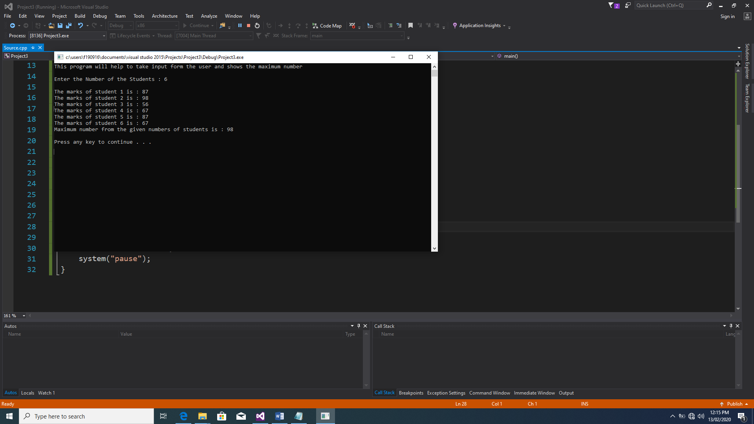

QUESTION NUMBER 5:

PROGRAM:

#include <iostream>

using namespace std;

int FIB(int a);

int main()

{

cout << "This program will help show the Fibonacci series " << endl;

int size=0;

cout <<endl<< "Enter the Number of the Fibonacci series : ";

cin >> size;

cout << endl << "Fibonacci series : ";

for (int i = 1; i <= size; i++)

{

cout << FIB(i)<<" ";

}

cout << endl << endl;

system("pause");

}

int FIB(int a)

{

if (a == 0 || a == 1)

return a;

return (FIB(a-1) + FIB(a-2));

}

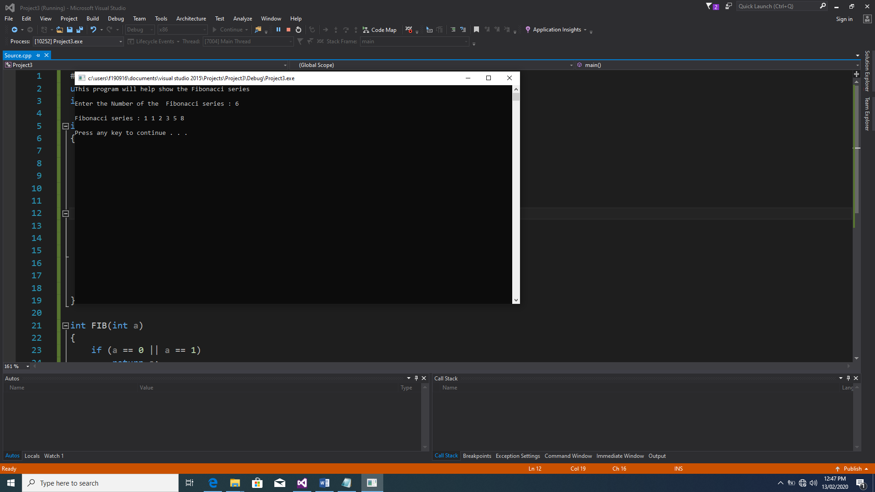

QUESTION NUMBER 4:

PROGRAM:

#include <iostream>

using namespace std;

int main()

{

cout << "This program will help to make a user-defined array " << endl;

int \*\*Double = NULL;

int row = 0, column = 0;

cout << "Enter the number of rows : ";

cin >> row;

cout << "Enter the number of column : ";

cin >> column;

Double = new int\*[row];

for (int i = 0; i < row; i++)

{

for (int j = 0; j < column; j++)

{

Double[i] = new int[column];

}

}

for (int i = 0; i < row; i++)

{

for (int j = 0; j < column; j++)

{

cout << "Enter value of " << i + 1 << " row and " << j + 1 << " coloumn : ";

cin >> Double[i][j];

}

cout << endl;

}

cout << "value of 2D Array : " << endl;

for (int i = 0; i < row; i++)

{

for (int j = 0; j < column; j++)

{

cout << Double[i][j]<<" ";

}

cout << endl;

}

delete[]Double;

Double = NULL;

cout << endl << endl;

system("pause");

}

